DCN LAB

Lab Report No 09



# Spring 2025

# Submitted by: Naveed Ahmad

Registration No: **22pwsce2165**

class Section: B

“On my honor, as student of University of Engineering and Technology, I have neither given nor received unauthorized assistance on this academic work.”

Student Signature: ______________

Submitted to:

# Dr. Yasir Saleem Afridi

Month Day, Year (22 05, 2025)

Department of Computer Systems Engineering

University of Engineering and Technology, Peshawar

**Introduction to Cisco Packet Tracer**

**Objectives:**

This lab aims to introduce Cisco Packet Tracer. Some specific topics covered in this lab are

* Downloading Cisco Packet Tracer from NetAcad
* Installing Packet Tracer
* Cisco Packet Tracer Overview
* Creating Devices
* Adding Modules
* Making Connections
* Creating Networks

**Lab Tasks**:

**TASK 1**: INSTALLATION AND OVERVIEW

**Download and Install Cisco Packet Tracer:**

1. **Visit the Cisco Networking Academy**: Go to the official Cisco Networking Academy's website at NetAcad.
2. **Sign Up/Login**: If you don’t have an account, you will need to create one. Log in if

you already have an account.

1. **Access the Download Page**: Once logged in, navigate to the 'Resources' or 'Download Packet Tracer' section.
2. **Download**: Choose the version of Packet Tracer you need based on your operating system (Windows, macOS, or Linux) and download it.
3. **Install**: Open the downloaded file and follow the installation prompts. Accept the license agreement and choose the desired installation directory.
4. **Launch**: After installation, open Cisco Packet Tracer from your desktop or start menu.

**Overview of Cisco Packet Tracer Interface:**

* 1. **Menu Bar**: Provides options like File, Edit, View, Options, Tools, Extensions, Window, and Help.
  2. **Main Tool Bar**: Contains shortcuts for commonly used tools such as New, Open, Save, Copy, Paste.
  3. **Common Tools Bar**: Provides access to selection, inspection, and drawing tools.
  4. **Logical/Physical Workspace and Navigation Bar**: Allows switching between logical (network topology) and physical views (physical layout of devices) of the network.
  5. **Workspace**: The main area where you drag and drop network devices to create network topologies.
  6. **Realtime/Simulation Bar**: Switch between realtime (the network runs in real time) and simulation mode (see how data moves through the network step-by- step).
  7. **Network Component Box**: Contains all the network devices and endpoints you can use.
  8. **Device-Type Selection Box**: Choose from different categories like routers, switches, and hubs.
  9. **Device-Specific Selection Box**: Select specific models or types of devices.
  10. 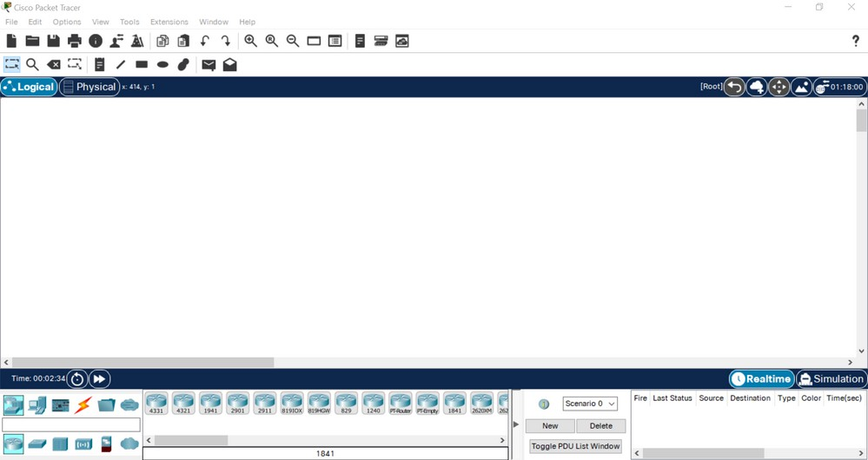**User Created Packet Window**: Allows you to create custom packets for testing.

**Task 2**: Creating Devices

1. **Select Device**: Click on the 'Network Component Box', choose a category, and select a device.
2. **Place Device**: Drag the device onto the workspace.
3. **Customize Device**: Double-click on the device to rename it or modify its properties.

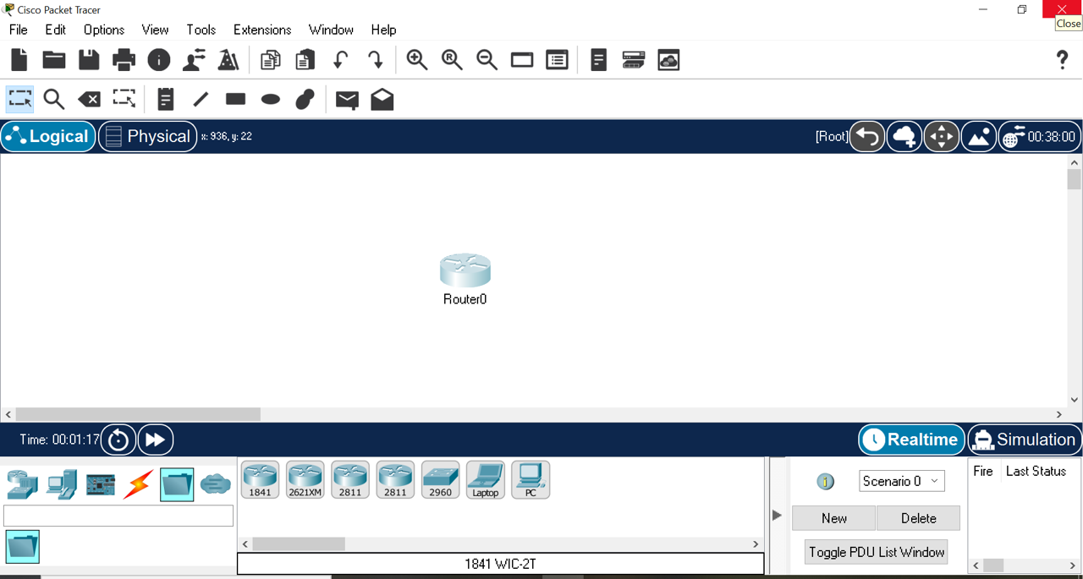**Output:**

**Task 3**: Making Connections

1. **Choose Cable Type**: From the 'Common Tools Bar', select the cable type needed for the connection (e.g., straight-through, crossover, or fiber).
2. **Connect Devices**: Click on one device, choose the specific port, and then click on another device to connect them.

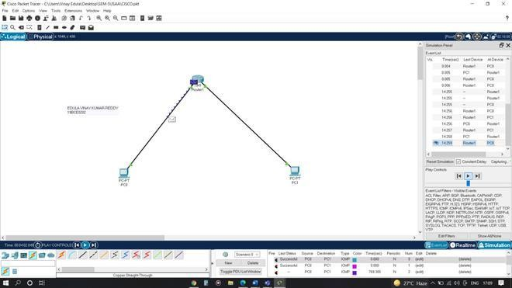**Output:**

**Task 4**: Creating Networks

1. **Design Topology**: Place at least three different devices (e.g., router, switch, PC) in the workspace.
2. **Connect Devices**: Use appropriate cables to connect devices based on the network topology design.
3. **Configure Devices**: Configure IP addresses and other network settings on each device.

**Network Description**: Provide details of the network, such as device roles and the network addressing scheme.

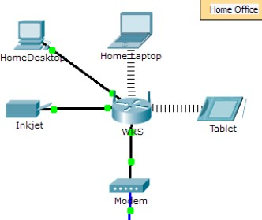**Output:**

**Task 5**: Connectivity Testing

**Ping Command:**

* 1. **Access Device Terminal**: Click on a PC or a router, then go to the CLI or Desktop tab and open the Command Prompt.
  2. **Run Ping Command**: Type **ping [destination IP address]** and press Enter.

**Testing**:

* + 1. **Document the Command**: Record the commands used and the output received.
    2. **Analyze Results**: Note whether the ping tests were successful (replies) or unsuccessful (request timed out).

**Output:**

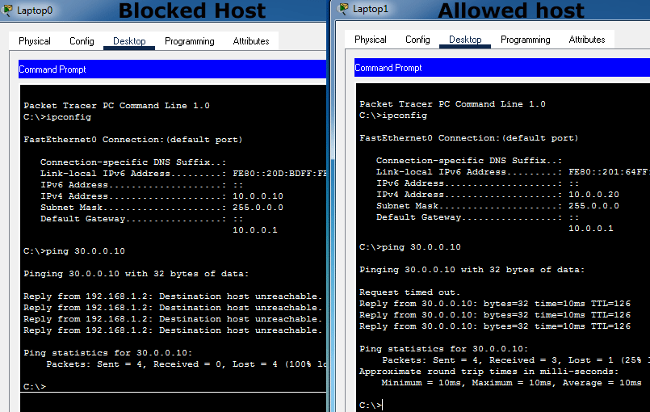

**Conclusion:**

In conclusion, we have successfully accomplished the objectives set forth in this laboratory session. Through hands-on tasks and theoretical exploration, we have gained valuable insights into the **packet tracer** domain. This experience has enriched our understanding of core concepts and their practical applications in the field. We look forward to applying this knowledge in future endeavors.